**Question1**:- Add a 10GB disk to the CentOS.

**Ans :-**

**Steps :-**

1.Click on CentsOs 64-bit.

2.Click on Edit virtual machine settings.

3.Click on Hard Disk and click on Add.

4.Select Hard disk and click on next.

5.Click on SCSI if it not detected click on IDE(you have to restart the system) and click on next.

6.Click on create a new virtual disk and click on Next.

7.Select the amount of size you required to add(in my case it is 10) and click on Store virtual disk as a single file and click on next.

8.And click on Finish.

9.Click on Ok. (Now you can see that 10 GB has to CentOs Virtual Machine).

**Step-1**

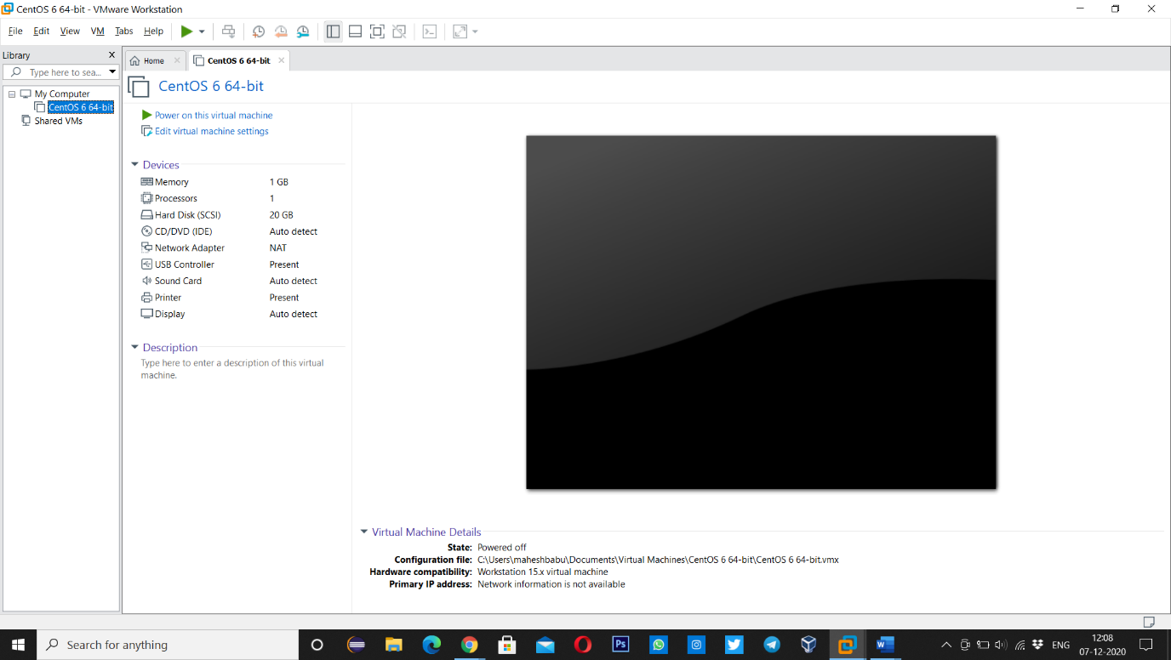

**Step-2 and Step-3**

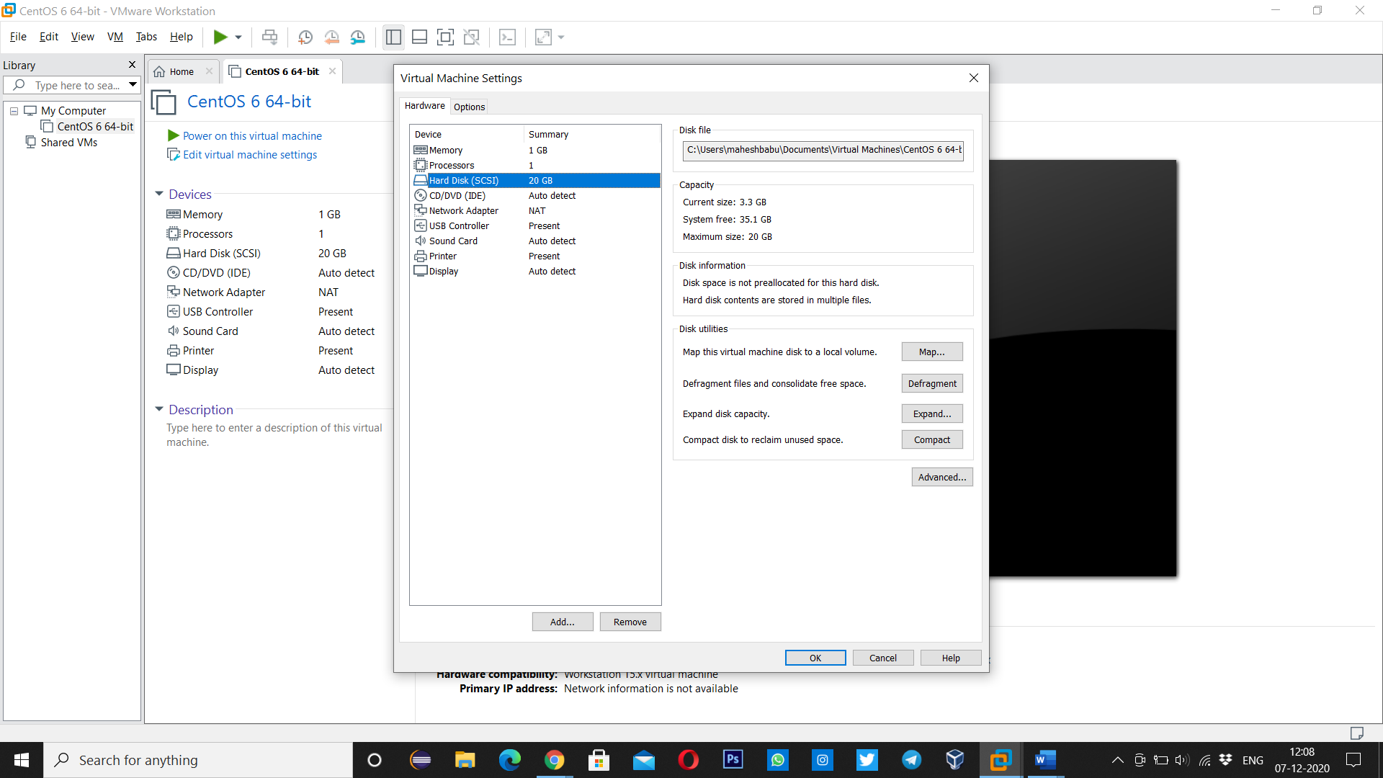

**Step-4**

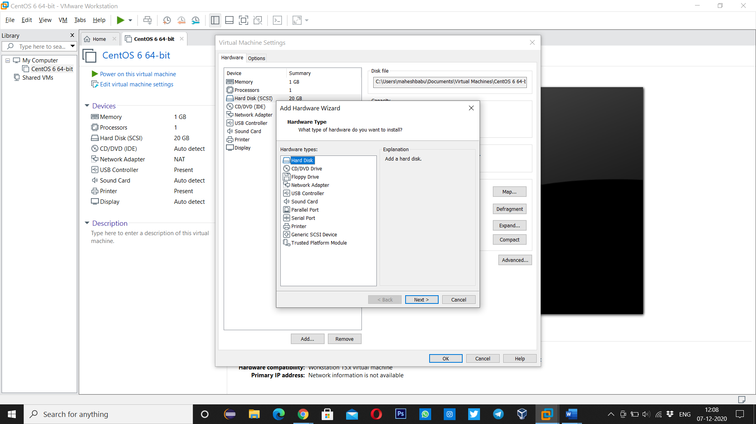

**Step-5**

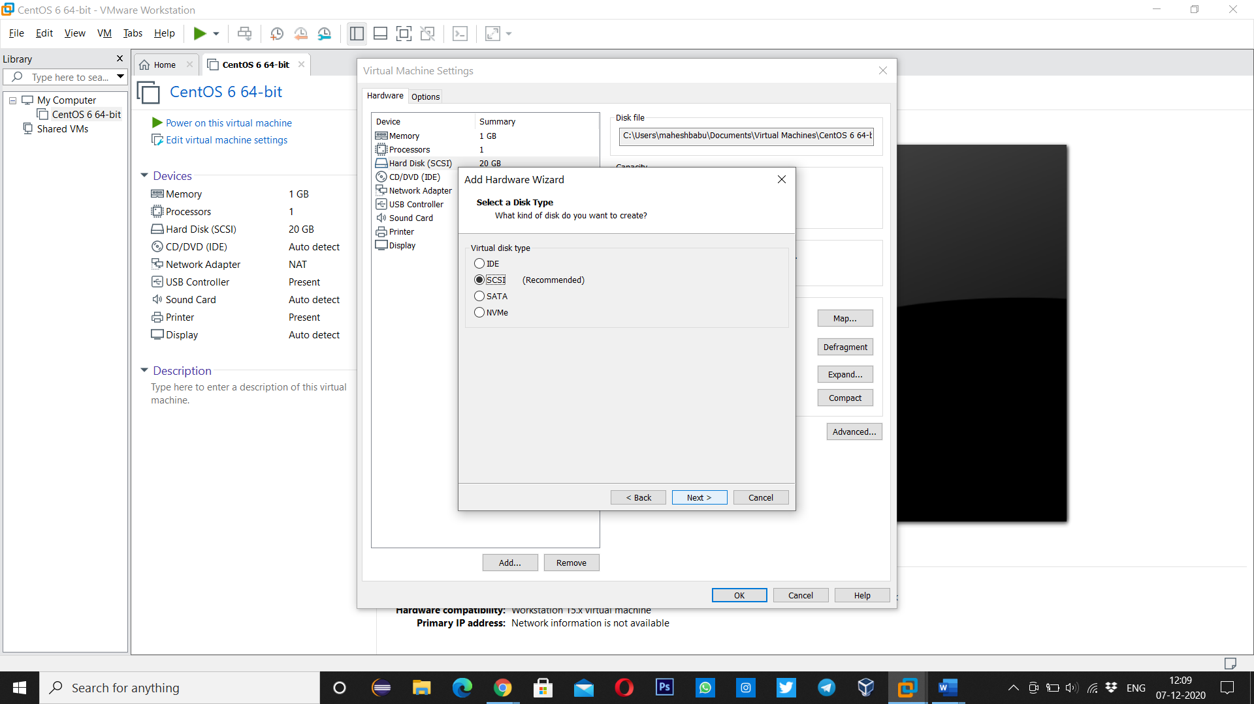

**Step-6**

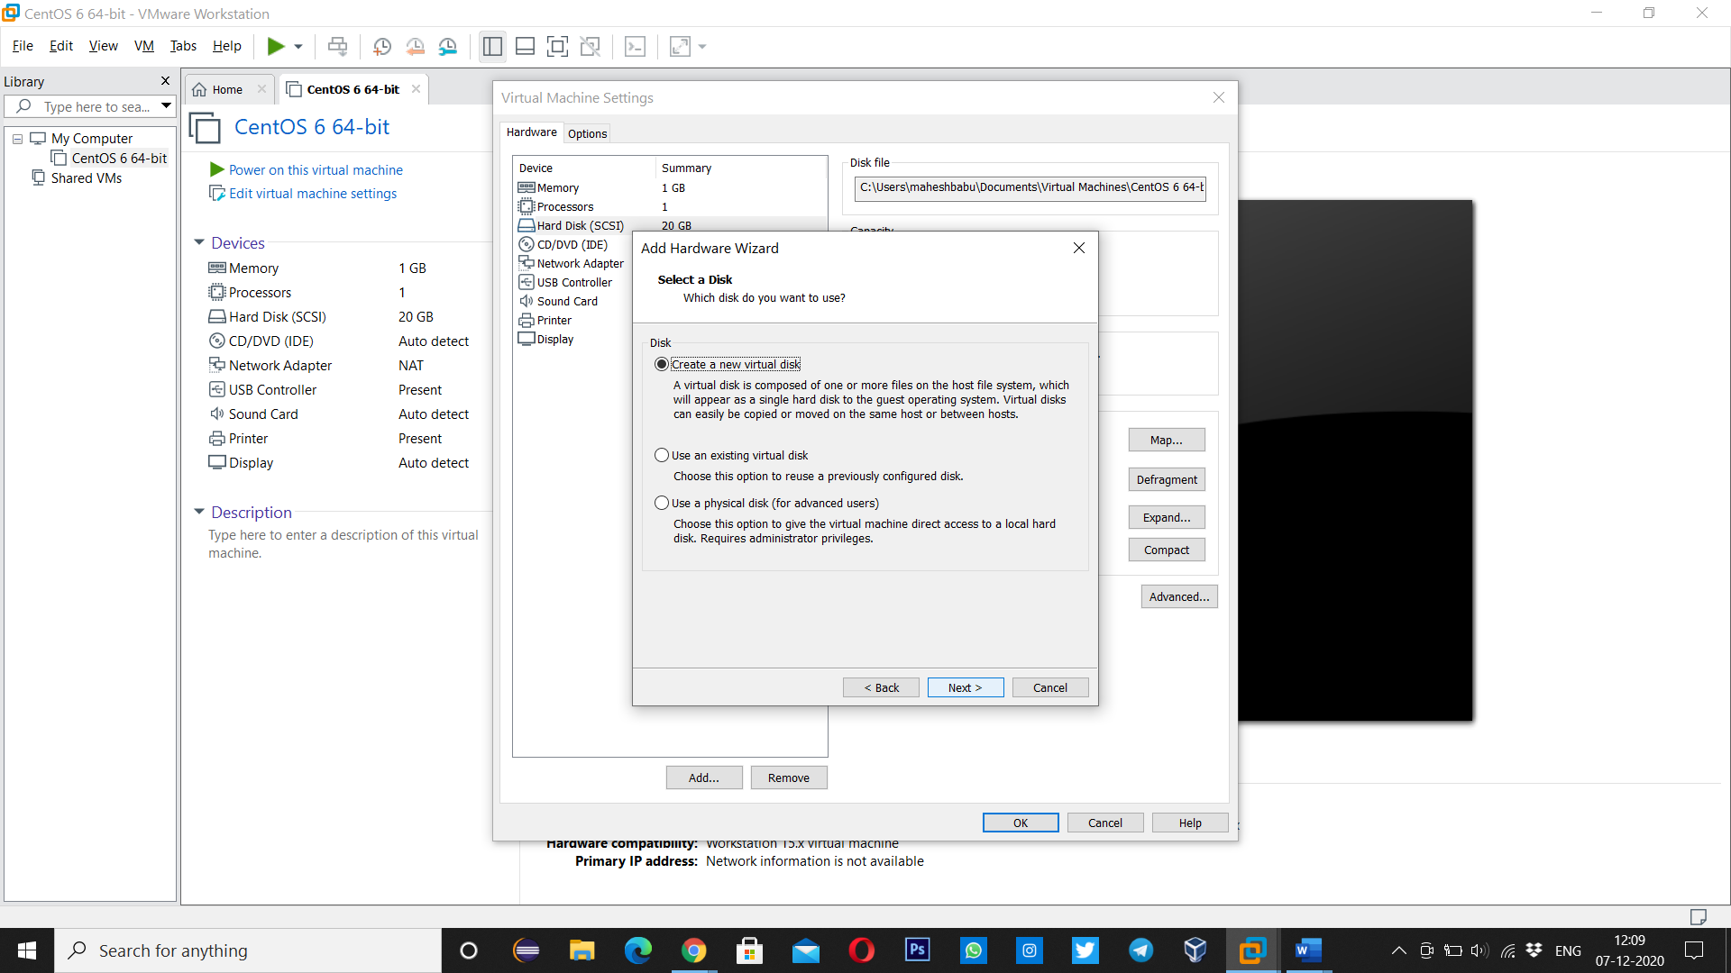

**Step-7**

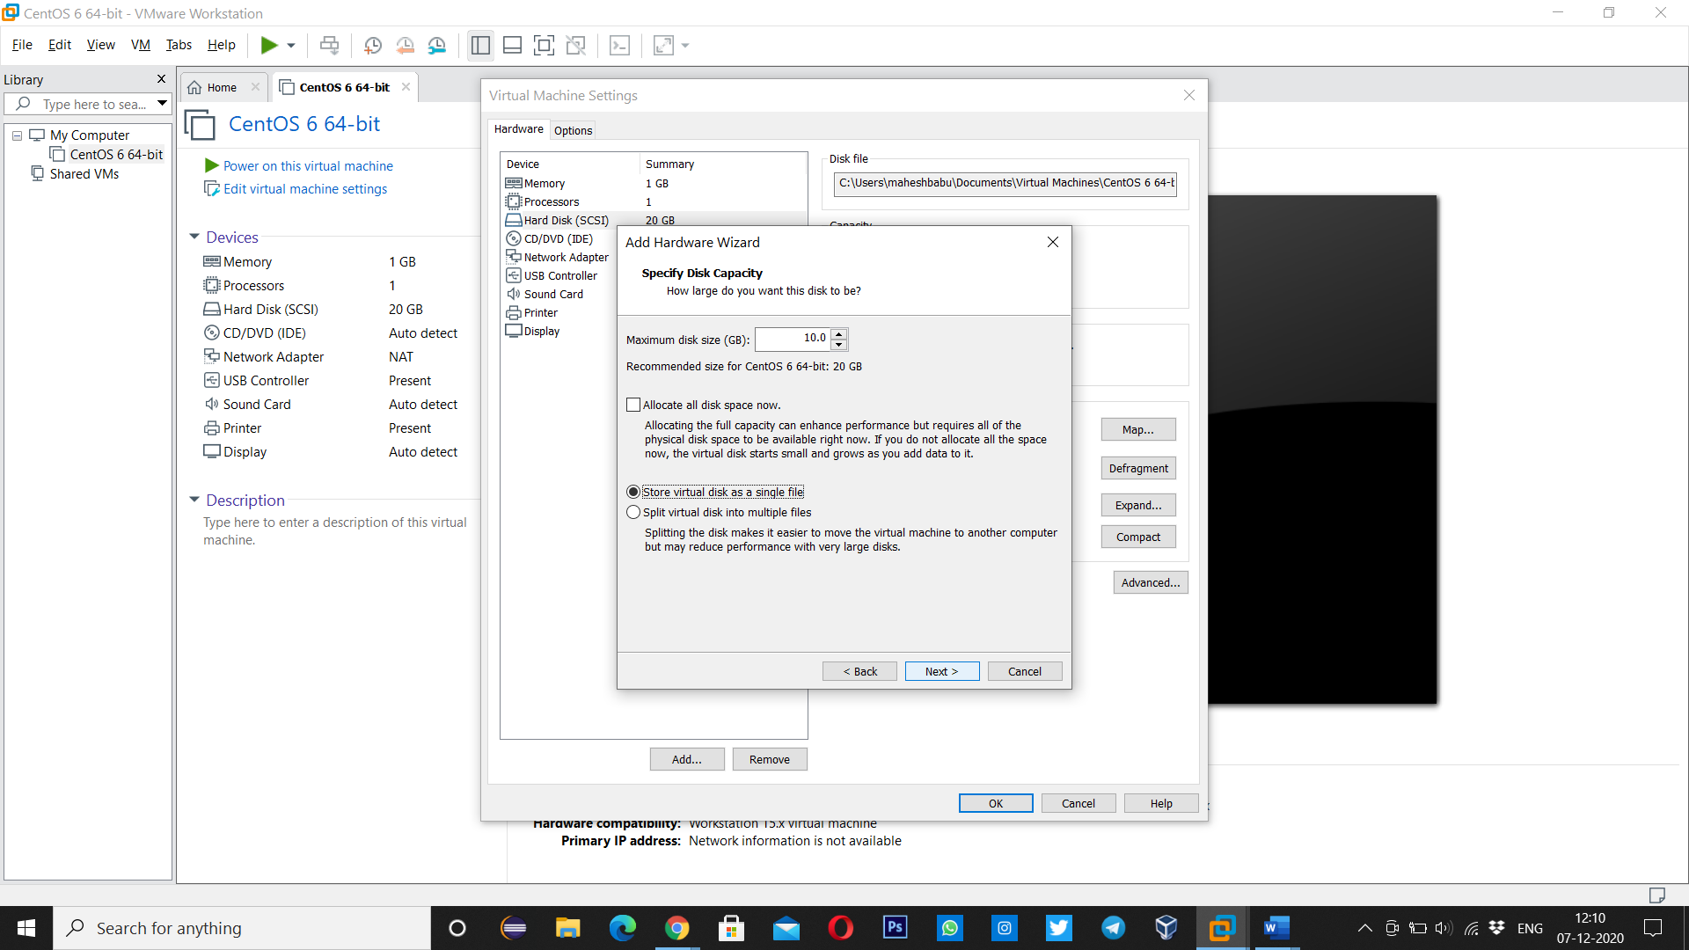

**Step-8**

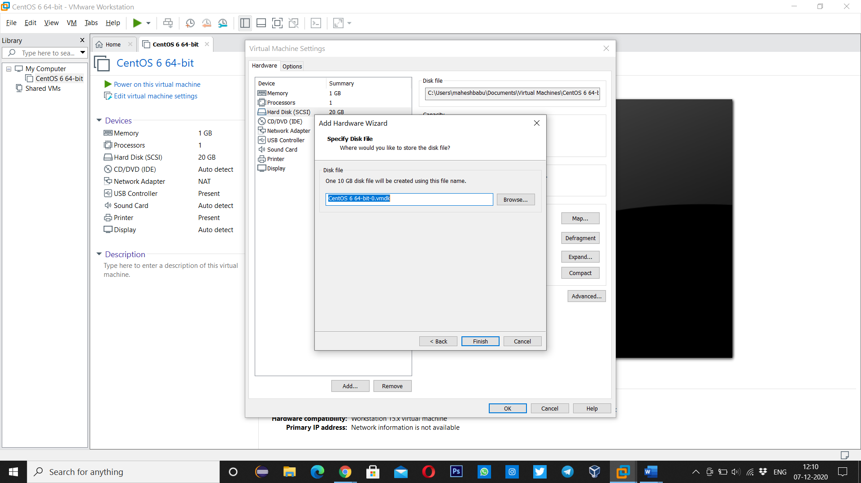

**Step-9**

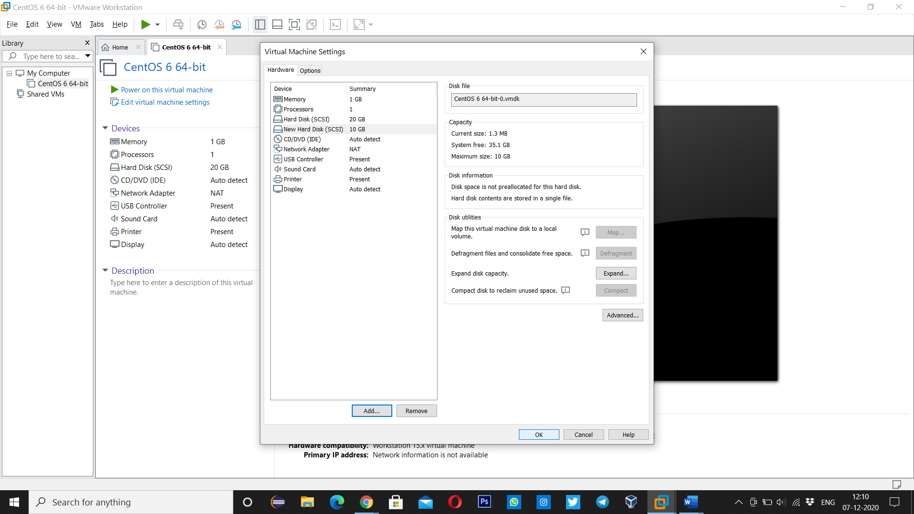

**Question-2 :-** Create 2 Partitions 4GB and 6GB of Space respectively.

**Ans :-**

Commands:- **lsblk🡪** to list information about all blocks present

Or

**fdisk -l(format disk)🡪** to list blocks

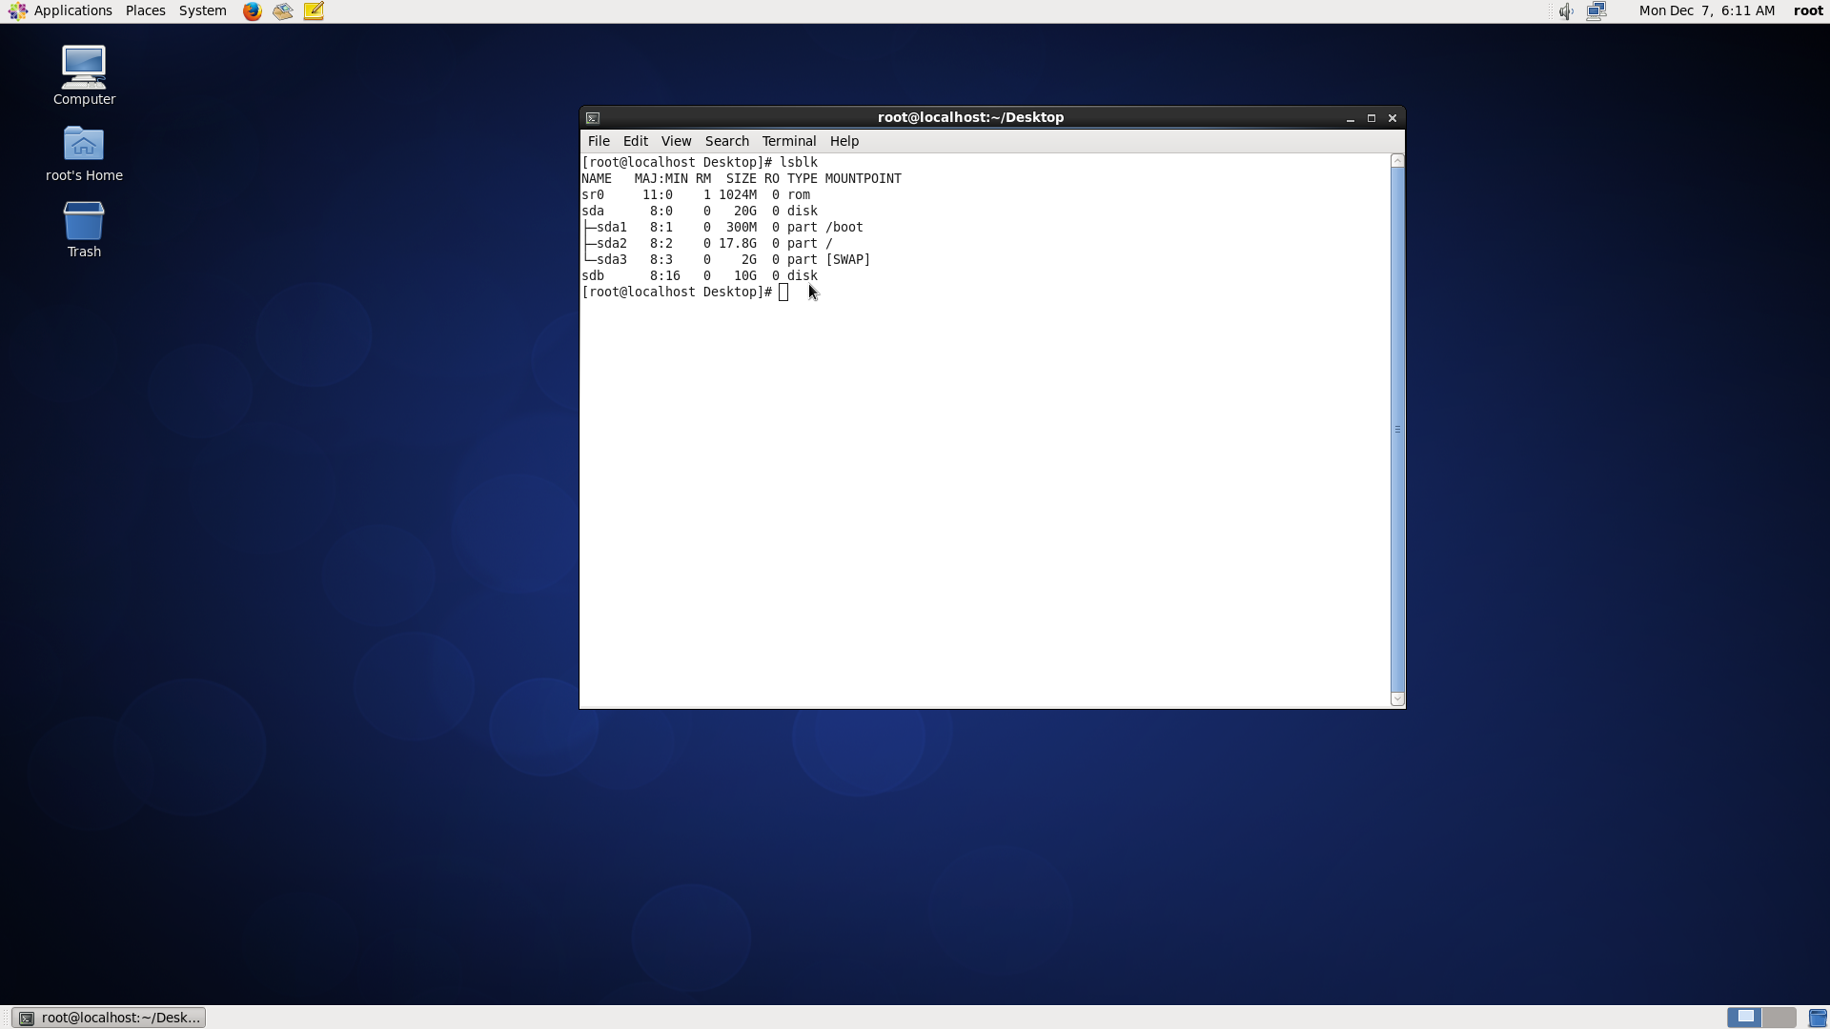

**fdisk /dev/sdb🡪** id of block to partition

**press m** to print menu of fdisk

**Press n** to create a new partition(select primary or extended, select partition number and select start and end cylinder) to partition.

**Press p** to print partition table

**press w** to write partition

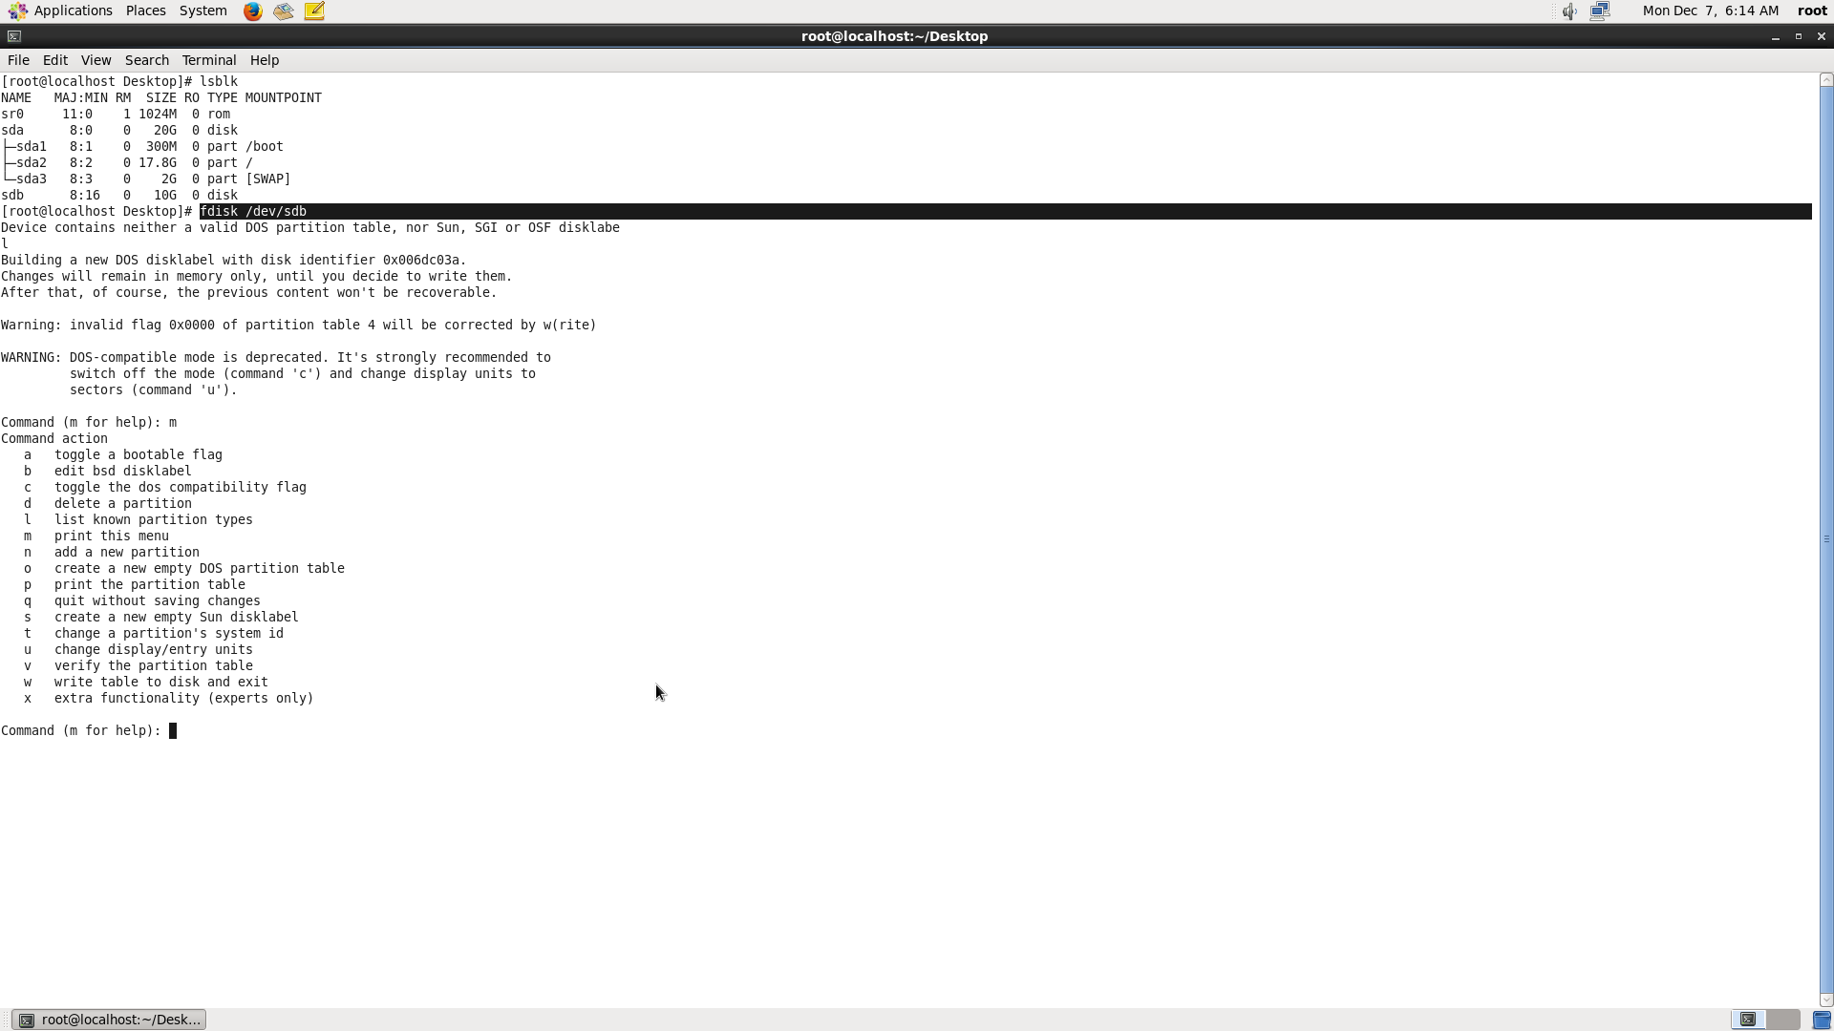

**Fig:** Shows list of blocks present

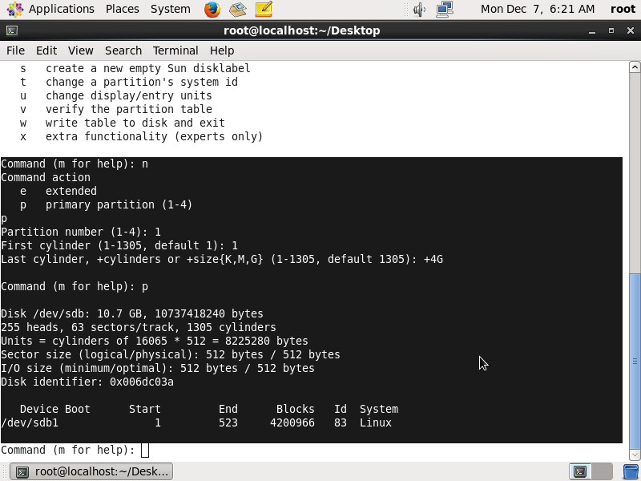

**Fig:** Shows to create a new primary partition of size 4GB

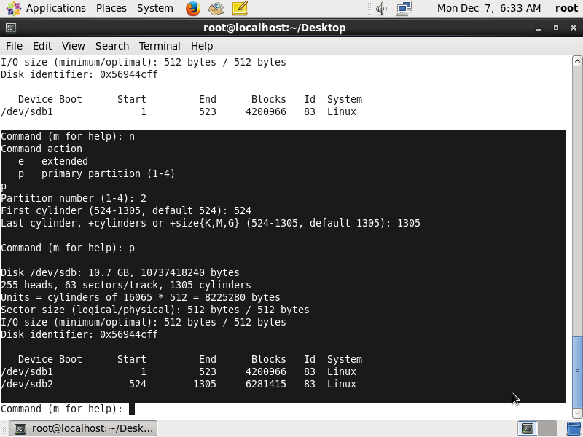

**Fig:** Shows to create a new primary partition of size 6GB

**Question-3 :- Format 4GB with xfs and 6GB with ext4 file system.**

**Ans :-**

Command:- **mkfs.xfs /dev/sdb1 🡪** formatting 4GB disk with xfs filse system

**mkfs.ext4 /dev/sdb2 🡪** formatting 6GB disk with ext4 filse system

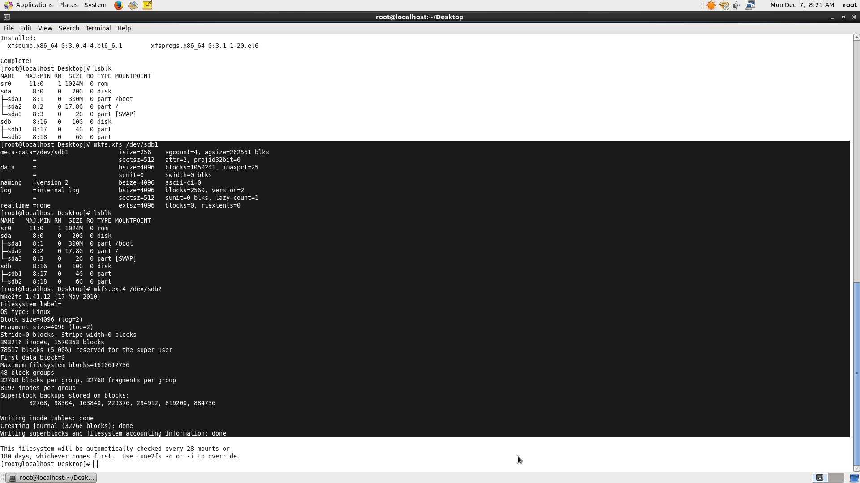

**Fig:** shows formatting 4GB and 6GB disk to xfs and ext4 file system

**Question-4 :- Mount 4GB and 6GB in /data and /music directory respectively.**

**Ans :-**

Command:- **mkdir /data /music🡪** make directories data and music to mount

**mount /dev/sdb1 /data🡪** mounting sdb1 to /data(temporary)

**mount /dev/sdb2 /music🡪** mounting sdb2 to /music(temporary)

**To mount permanently :-**

edit **vi /etc/fstab**

**/dev/sdb1 /data xfs defaults 0 0**

**/dev/sdb2 /music ext4 defaults 0 0**

and

**:wq 🡪** to write and quit

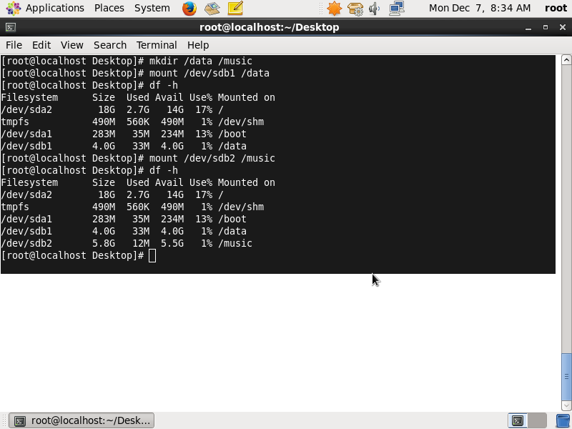

**Question-5 :-** Create one file of 1GB in each of the mount point created above.

**Ans :-**

Command:- **dd if=/dev/zero op=/music/size1 bs=1G count=1** 🡪

dd 🡪 copy command

if 🡪 input file

/dev/zero 🡪 contains all zeros to copy

Op 🡪 output file

bs 🡪block size of size 1GB

count 🡪 no of blocks to create

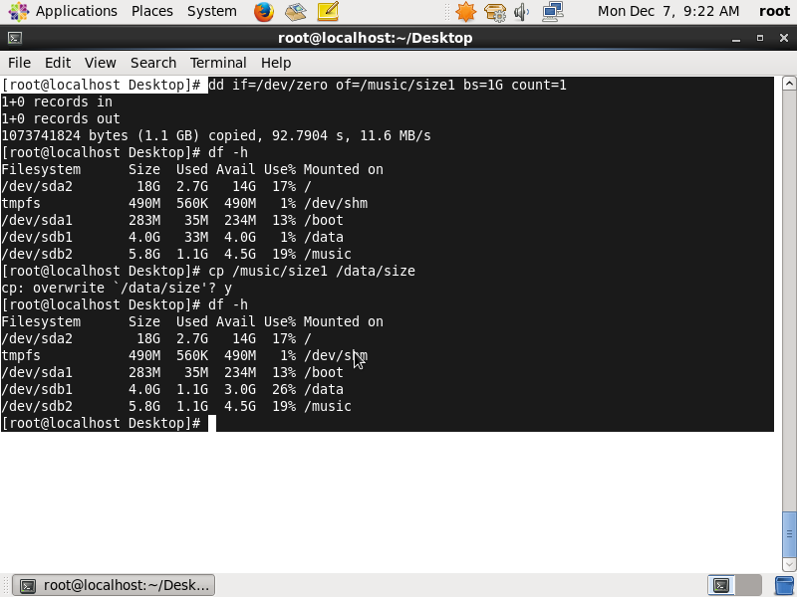

**Fig**: Shows creation of 1GB file in /data and /music

**Question-6 :- Verify the disk Consumption and disk space free in the mounted partitions.**

**Ans :-**

command:- **df –h 🡪** To verify disk consumption and free disk space in the mounted partitions.



**Fig:** Shows used and free disk space in mounted partitions